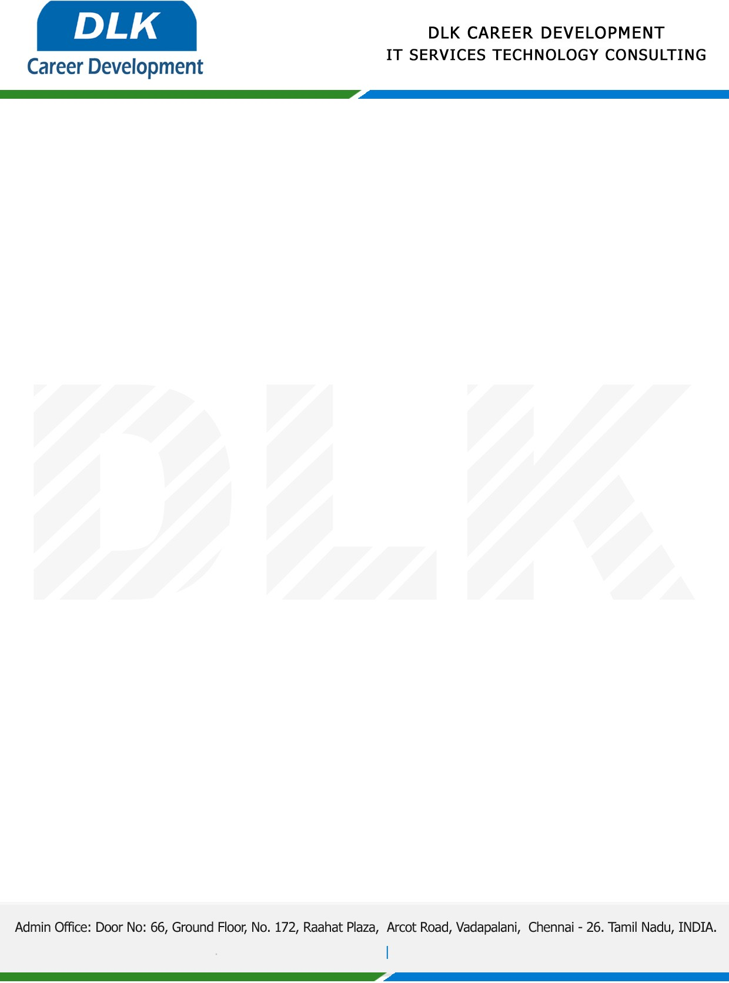

**Date: 02/ March /2023**

**SUB: PROJECT COMPLETION CERTIFICATE**

This is to certify that **MS JAYASHREE T (REG NO:** **832100390) MSC- Computer Science,** final year student **Valliammal College for Women, Chennai** has Successfully Completed the Project Work under the domain of “**Java”** in our organization during the Period **(January 2023 to May 2023).**

**Topic:** Food and shelter for helpless people.

We appreciate your interest in **DLK CAREER DEVELOPMENT**

**“Best Wishes for Your Future Endeavors “**

